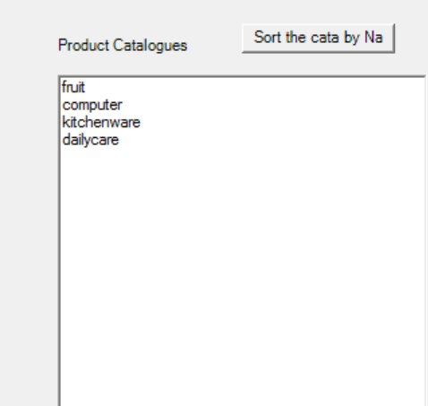 some default catalogues have been preloaded,

But still users can add their own catalogues using 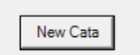 , as per operation 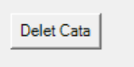deleting chosen catalogue.

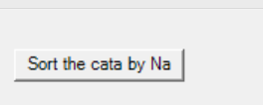 By hitting this button, the catalogues will be grouped in an ascending alphabetical order.

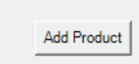 This button opens adding products window, so that products can be added to the according catalogue.

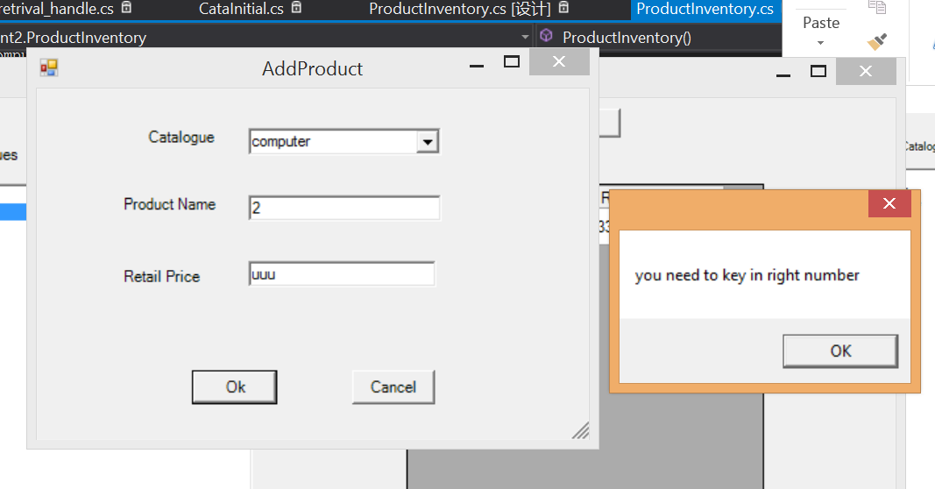In terms of exception handling , a message box is shown.

When some products are added under a certain catalogue, by single click the catalogue name, the products dataview will show in the according products information. 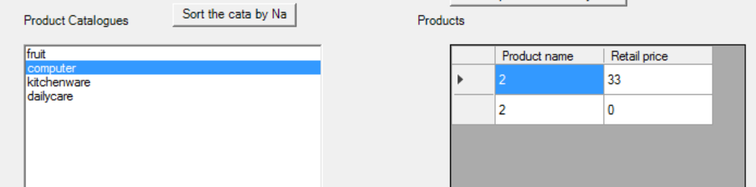

By selecting a certain row 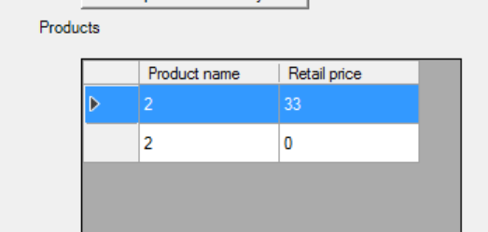 (like this), and hit , the chosen product will be removed from the according catalogue.

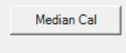 this gives users options of calculating median per catalogue or as a whole.

By hitting 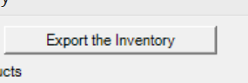 , the program will export a XML file containing the inventory information to a certain address. 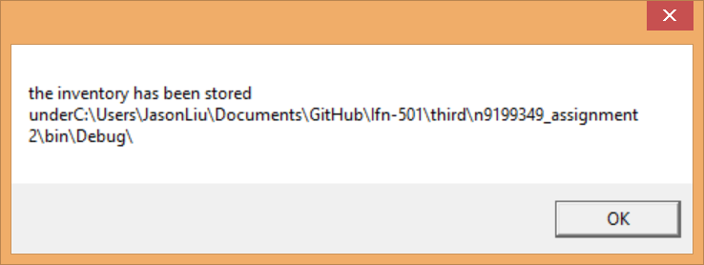.

The xml files looks like this 